1-Install CentOS /RHEL
2-What is the difference between cat and more command?
The cat command is the simplest way to view the contents of a file. It displays the contents of the file(s) specified on to the output terminal.
The cat command is all well and good for small files. But, if the file is large, the contents will zoom past and we’ll only see the last screen worth of content.
One way to overcome this is by using the more command. The more command displays the contents of the file one screen at a time for large files. If the contents of the file fit a single screen, the output will be the same as the cat command.
3-What is the difference between rm and rmdir using man?
You use the rm command to delete files and directories in Linux. For directories, this command can be used to delete a directory entirely – that is, it deletes a directory and all files and sub-directories within the directory.
You use the rm command to delete files and directories in Linux. For directories, this command can be used to delete a directory entirely – that is, it deletes a directory and all files and sub-directories within the directory.
rmdir: It is the equivalent of the rm command with the -d flag: rm -d.
When you use rmdir on a non-empty directory, you get this error: rmdir: [folder]: Directory not empty.

4-Create the following hierarchy under your home directory:
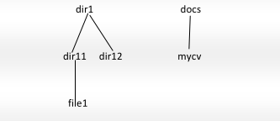

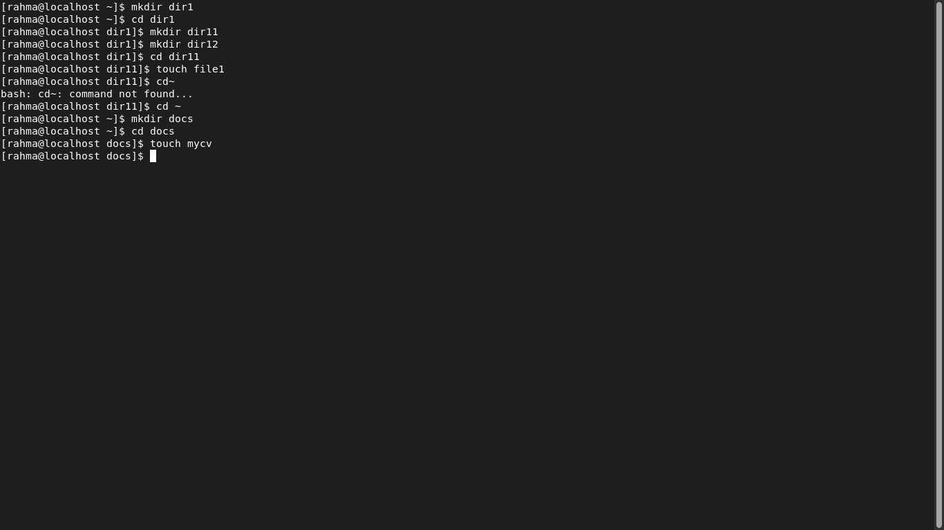
a. Remove dir11 in one-step. What did you notice? And how did you overcome that?

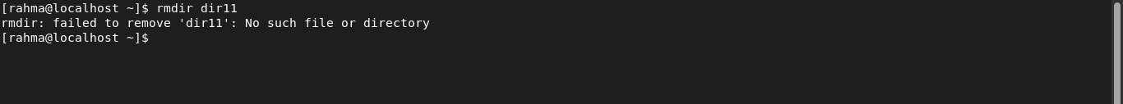
b. Then remove dir12 using rmdir –p command. State what happened to the
hierarchy (Note: you are in your home directory).

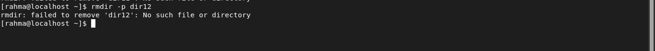

c. The output of the command pwd was /home/user. Write the absolute
and relative path for the file mycv

/home/rahma/docs/mycv
../home/rahma/docs/mycv

5-Copy the /etc/passwd file to your home directory making its name is mypasswd.

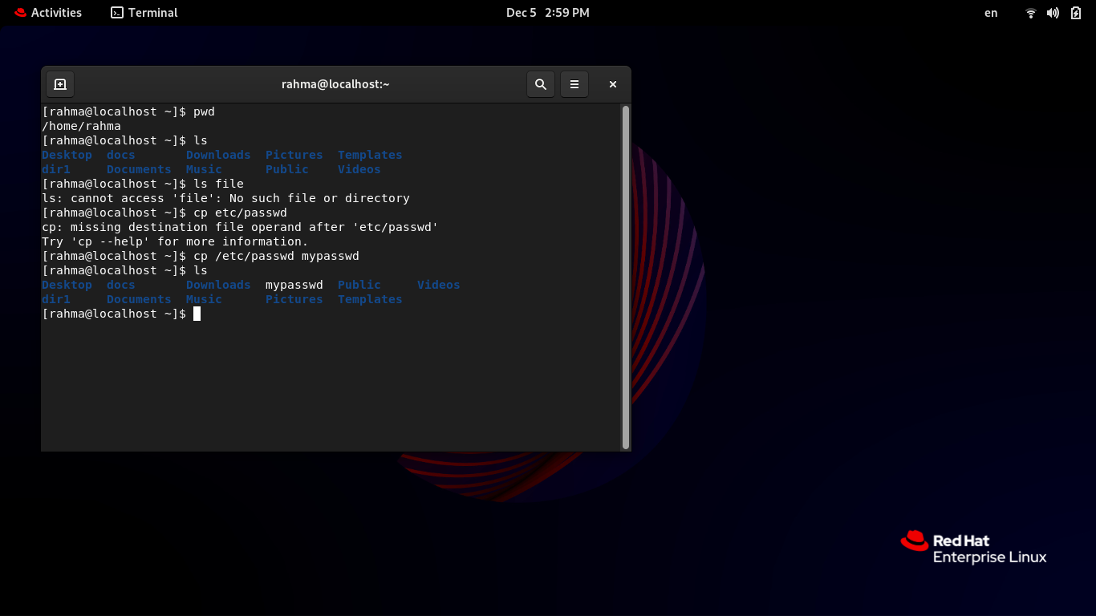

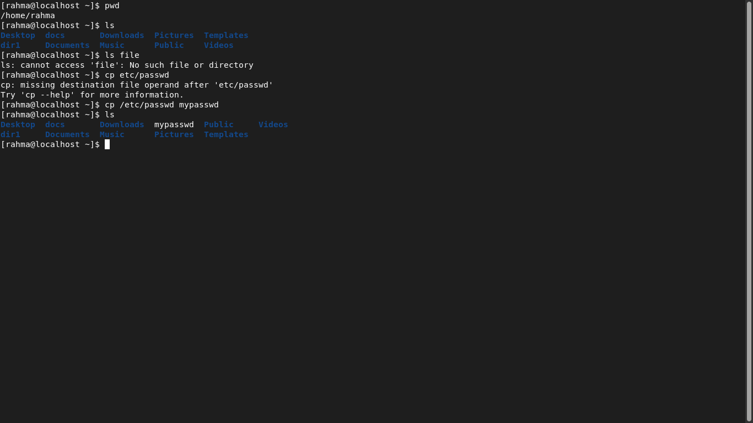

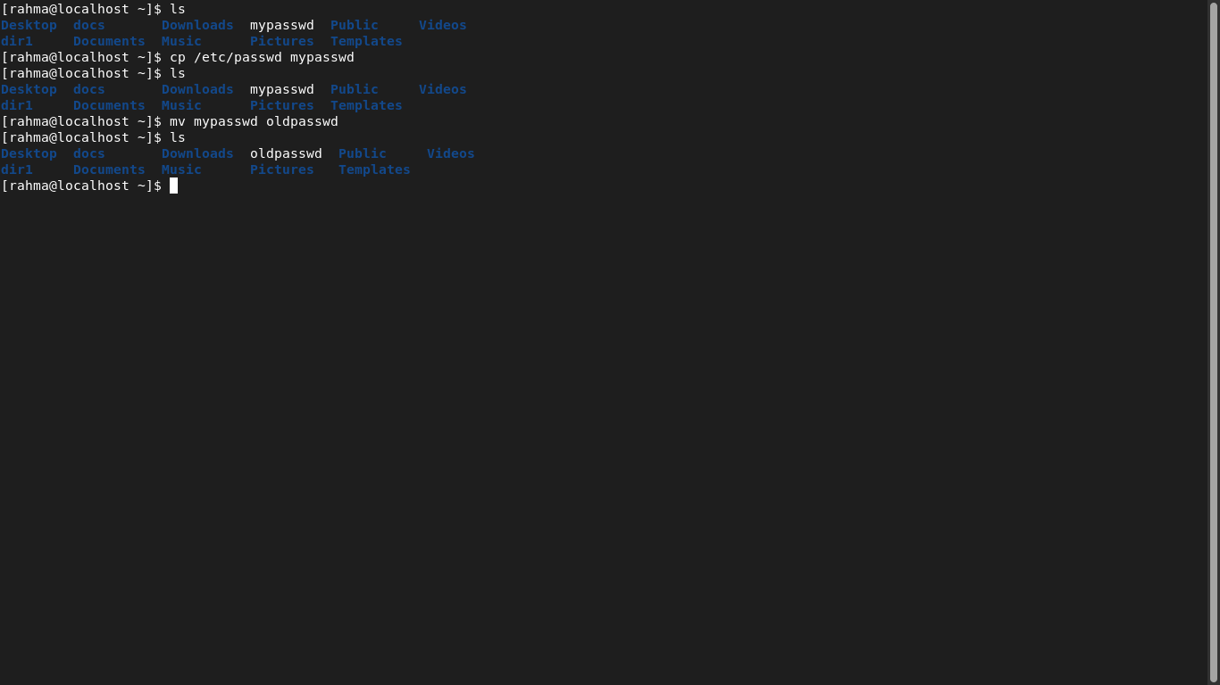
6-Rename this new file to be oldpasswd.

7. You are in /usr/bin, list four ways to go to your home directory

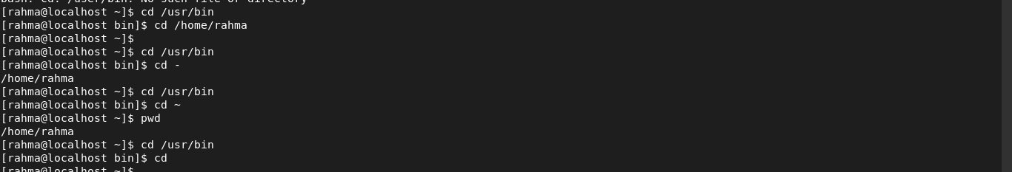

8. List Linux commands in /usr/bin that start with letter w

9. Display the first 4 lines of /etc/passwd

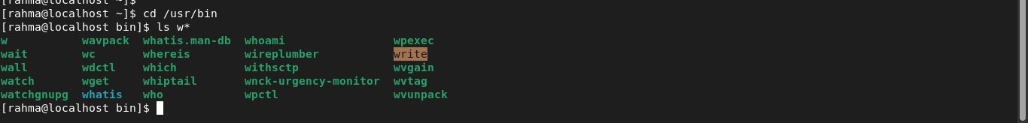

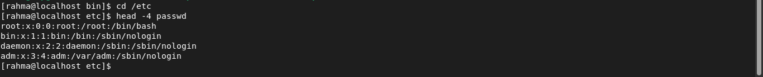
10. Display the last 7 lines of /etc/passwd

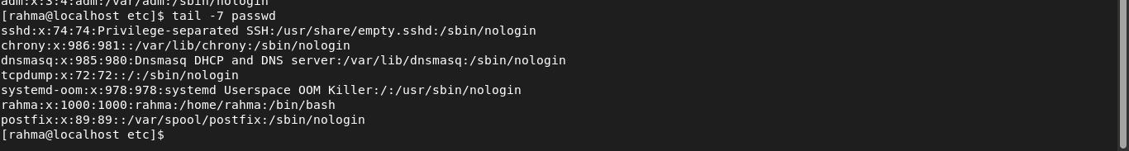
11. Display the man pages of passwd the command and the file sequentially in one command.
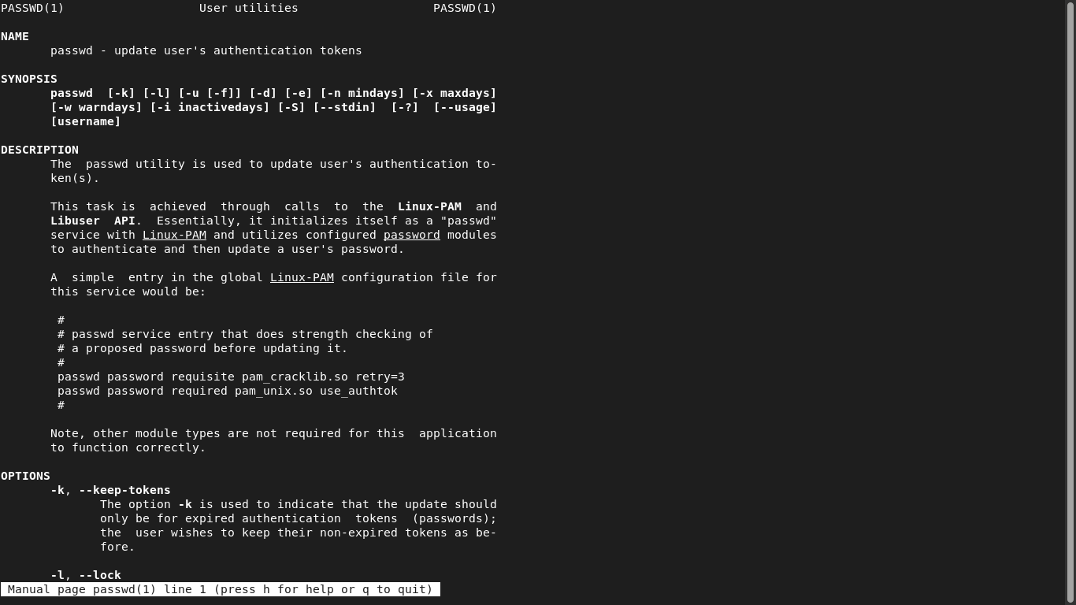

12. Display the man page of the passwd file.

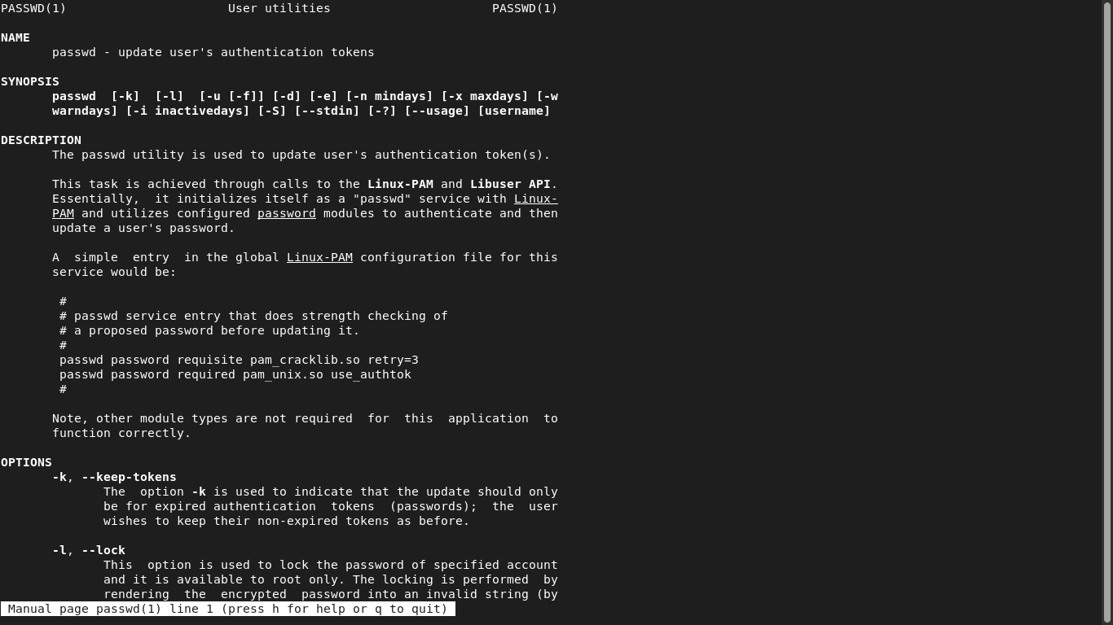
13. Display a list of all the commands that contain the keyword passwd in their man page.

